**DCN LAB**

**Lab Report No 07**



# **Spring 2025**

# **Submitted by: Naveed Ahmad**

**Registration No: 22pwsce2165**

**class Section: B**

**“On my honor, as student of University of Engineering and Technology, I have neither given nor received unauthorized assistance on this academic work.”**

**Student Signature: ______________**

**Submitted to:**

# **Dr. Yasir Saleem Afridi**

**Month Day, Year (22 05, 2025)**

**Department of Computer Systems Engineering**

**University of Engineering and Technology, Peshawar**

## **LAB OBJECTIVES:**

### **Objectives of the Lab:**

## **We’ll take a quick look at DHCP. Recall that DHCP is used extensively in corporate, university and home-network wired and wireless LANs to dynamically assign IP addresses to hosts (as well as to configure other network configuration information).**

**DHCP EXPERIMENT:**

**1. Begin by opening the Windows Command Prompt application (which can be found in your Accessories folder). As shown in Figure 1, enter “ipconfig /release”. The executable for ipconfig is in C:\windows\system32. This command releases your current IP address, so that your host’s IP address becomes 0.0.0.0.**



**2. Start up the Wireshark packet sniffer, as described in the introductory Wireshark**

**lab and begin Wireshark packet capture.**

**3. Now go back to the Windows Command Prompt and enter “ipconfig /renew”.**

**This instructs your host to obtain a network configuration, including a new IP address. In Figure 1, the host obtains the IP address 192.168.1.101**



**4. Wait until the “ipconfig /renew” has terminated. Then enter the same command**

**“ipconfig /renew” again.**



**5. When the second “ipconfig /renew” terminates, enter the command**

**“ipconfig/release” to release the previously-allocated IP address to your computer.**



**6. Finally, enter “ipconfig /renew” to again be allocated an IP address for your computer.**



**7. Stop Wireshark packet capture.**

## **Are DHCP messages sent over UDP or TCP**

**DHCP messages are typically sent over UDP protocol and use UDP port 67 for the server and UDP port 68 for the client. These ports are well-known and standardized for DHCP communication.**

**Draw a timing datagram illustrating the sequence of the first four-packet Discover/Offer/Request/ACK DHCP exchange between the client and server. For each packet, indicated the source and destination port numbers. Are the port numbers the same as in the example given in this lab assignment?**

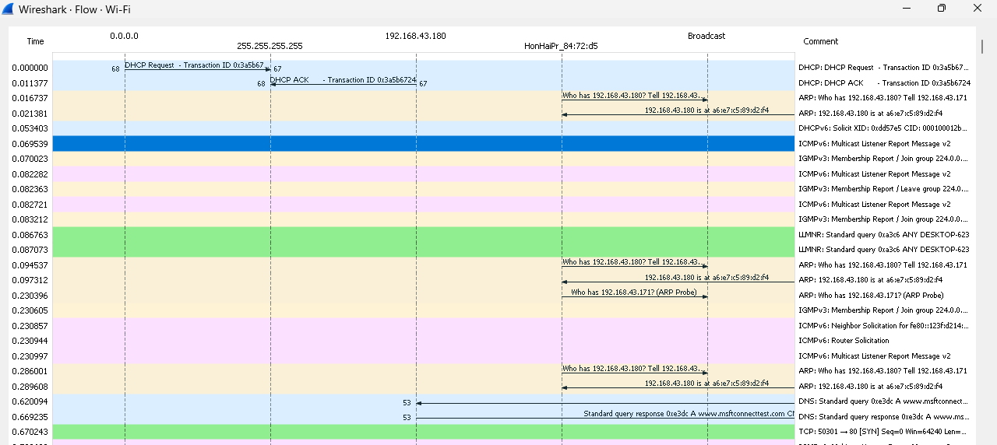

## **What is the link-layer (e.g., Ethernet) address of your host?**



## **What values in the DHCP discover message differentiate this message from the DHCP request message?**

**Option 53 is different.**

## **What is the value of the Transaction-ID in each of the first four (Discover/Offer/Request/ACK) DHCP messages? What are the values of the Transaction-ID in the second set (Request/ACK) set of DHCP messages? What is the purpose of the Transaction-ID field.**

**Answer:**

**The Transaction-ID field plays a vital role within the DHCP (Dynamic Host Configuration Protocol) protocol as it serves to provide a distinctive identifier for a DHCP transaction between a client and a server. Its primary objective is to enable the seamless matching of DHCP messages between the client and server, ensuring the preservation of the transaction's context throughout the process.**

## **A host uses DHCP to obtain an IP address, among other things. But a host’s IP address is not confirmed until the end of the four-message exchange! If the IP address is not set until the end of the four-message exchange, then what values are used in the IP datagrams in the four-message exchange? For each of the four DHCP messages (Discover/Offer/Request/ACK DHCP), indicate the source and destination IP addresses that are carried in the encapsulating IP datagram.**

**Answer:**

**Discover IP address   =  255.255.255.255  
Offer IP address          =  192.168.43.171  
Request IP address    =  255.255.255.255  
ACK IP address           =  192.168.43.171**

## **What is the IP address of your DHCP server?**



## **What IP address is the DHCP server offering to your host in the DHCP Offer message? Indicate which DHCP message contains the offered DHCP address.**

**The IP address in which the DHCP server is offering to my host in the DHCP Offer message is 192.168.43.171. Option 53 contains the DHCP Message type with a length of 1 and the DHCP offer is (2).**

## **Explain the purpose of the router and subnet mask lines in the DHCP offer message.**

**Answer:**

**Within the DHCP Offer message, the router line serves to indicate the IP address of the default gateway or router that the client should utilize for accessing networks beyond its local subnet. This information enables the client to establish connectivity with external networks effectively.**

**Additionally, the subnet mask line within the DHCP Offer message informs the client about the specific subnet mask it should employ. This instruction guides the client in properly configuring its network settings to align with the designated subnet, ensuring accurate communication within the network environment.**

## **Explain the purpose of the lease time. How long is the lease time in your experiment?**

**Answer:**

**In my case, the lease time is 360 seconds. The purpose of this is to determine the duration for which the DHCP server assigns an IP address to a client.**

## **What is the purpose of the DHCP release message? Does the DHCP server issue an acknowledgment of receipt of the client’s DHCP request? What would happen if the client’s DHCP release message is lost?**

**Answer:**

**The client sends a DHCP release message to inform the DHCP server about its intent to relinquish the leased IP address. If, by chance, the client's DHCP release message is not successfully transmitted, it can result in the expiry of the lease or exhaustion of the IP address pool.**